**Terms of Reference for Baseline Survey**

**

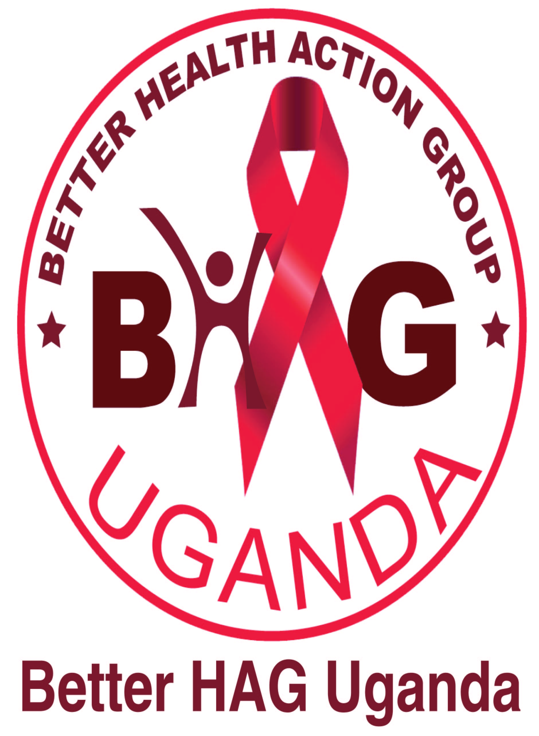

Better HAG Uganda (Better Health Action Group Uganda) is seeking to hire a consultant to carry out a baseline survey on the “*Leveraging Strategies of Positive Action towards Reducing Violence against Women and Girls*” project, an AWDF-funded program focusing on protecting the rights of rural women and girls against all forms of violence. The objective is to gather relevant baseline data for key project indicators to enable

1. the analysis of the communities’ knowledge, attitudes and practices of harmful Practices that affect gender based violence
2. ascertaining the magnitude of response by different stakeholders to reduce the incidence of violence against women and girls
3. measuring the results and impact throughout and at the end of the project.

**1) Background**

Better HAG Uganda is a non-profit making Non-Governmental Organization (NGO) incorporated with limited liability and registered with the Uganda National NGO Board. It was formed by a group of health rights and development activists in 2008 to respond to the poor sexual and reproductive health and rights (SRHR) especially among women and the youth; high HIV incidence and prevalence rates, increasing maternal, neonatal and child mortality ratios as well as the general inadequate support for the ever growing number of disadvantaged children country wide. The organization has since 2010 integrated activities consistent with sustainable environment and natural resources management in contribution to the global campaign towards climate change mitigation and/or adaptation.

Better HAG Uganda is one of the pro-active NGOs dedicated to employing the human rights based approach towards uplifting the health and safety of women and girls. The organization is currently implementing a project in Bubulo County East of Manafwa district benefiting thousands of women and girls including their families and communities.

The goal of equality between women and men and the promotion of women's rights are enshrined in international conventions and commitments such as CEDAW, the Beijing Platform for Action and the Millennium Development Goals (MDGs). In addition to these, this project is also consistent with Uganda national laws, policies and action plans to fight gender based violence and promote gender equality and equity. These include among others; the Uganda Constitution, Domestic Violence Act, the Uganda Gender Policy and the National Action Plan on Women (2007).

Better HAG Uganda has successfully been awarded a 2-year grant funding from the African Women’s Development Fund for a project titled “*Leveraging Strategies of Positive Action towards Reducing Violence against Women and Girls*” aimed at improving the health and safety of women and girls through combating all forms of gender based violence (VAW/G) and its effects. Ultimately, the project aims to build a protective environment for women and girls to be free from violence, including negative traditional practices in Manafwa district. It seeks to do this by **focusing on social change,** addressing patriarchy (a root cause for many harmful practices against women and girls including forced/child marriage, widow inheritance, sexual violence, dowry related violence; among others); rallying support from all leaders for a violence free environment and, by **supporting implementation of the existing legislative framework for** addressing violence against women and girls.

The project specifically targets:

* 480 individuals (including among others; clan heads who are the leaders of customary law, religious leaders, women and girls) participating in community dialogues to generate discussion at the local level on harmful traditional practices which are permissive of violence against women and girls
* Over 800 men and boys to participate in the anti-VAW response
* Social actors i.e. the Police, health workers, magistrates and Local council courts in not only expediting but also giving priority to cases in relation to violence against women and girls.
* Over 2400 individuals (including 1800 women and girls) through community outreaches with legal advice, advocacy and general sensitization of communities on the evil in GBV (VAWG).
* 200 women and adolescent girls experiencing violence who will receive appropriate care and referral through Community Referral and Protection (COREP) centers

The intervention will centre on:

1. **Legal change** by advocating for implementation of existing laws that address gender based violence. This includes fostering legal literacy for women and girls in relation to GBV
2. **Social change** by building communities, women’s, men’s, boys’ and girls’ capacity as agent of change
3. **Responding to the needs of girls at risk of forced/early marriages and married girls** through activities with peers, sexual and reproductive health (SRH) education and support services
4. **Strengthening support mechanisms** through COREP centers
5. **Addressing gender-based violence and gender inequality**: this project highlights the inter-related consequences and features of violence against women and girls
6. **Mind shift** especially for leaders of customary law (i.e. traditional/cultural leaders and clan heads) in appreciating the harm in VAWG and therefore changing their attitudes and perception in favor of women and girls’ rights
7. **Capacity building** through training community paralegals (CoPs) to traverse communities and help victims and potential victims with the crucial knowledge on the legislative processes of dealing with violence. This will be done through confidential legal advice and referrals

We have designed a detailed monitoring & evaluation (M&E) plan which this baseline forms a part of.

The baseline is an important element in the M&E plan, enabling us to understand the situation at the beginning of the project and aiming to identify tools and approaches to measure project indicators and strengthen the indicators in the M&E framework.

**2) Baseline Purpose and scope**

Better HAG Uganda (Better Health Action Group Uganda) is seeking to hire a consultant to carry out a baseline survey on the “*Leveraging Strategies of Positive Action towards Reducing Violence against Women and Girls*”, an AWDF-funded program focusing on protecting the right of rural women and girls against all forms of violence in Manafwa district of Eastern Uganda. The project has high demands in terms of the quantity and quality of data to be collected and used by multiple-stakeholders, and will require a high level of rigor and investment to meet the M&E standards expected. The baseline study is **intended to provide programme staff with detailed baseline data on key project indicators to enable changes in girls and boys, women and men and duty bearers to be measured over the course of the project**. The data collected will be both qualitative and quantitative in nature, and will include information gathered on the outcome indicators and on knowledge, attitudes and practices on GBV (specifically VAW&G). The data collected will also be used during the training of boys and girls, men and women and local leaders, and for advocacy purposes. It should additionally develop relevant practical tools and approaches for on-going project monitoring and learning.

The design and implementation of the baseline must also take into account and abide by Better HAG Uganda’s beneficiary-centered Community Development principles. This means, for example, ensuring women and girls are at the centre of the baseline research, that principles of gender equality, inclusion and non-discrimination are considered and acted upon throughout, and that the meaningful participation of women, girls and other key stakeholders is promoted in the design and implementation of the baseline.

**3) Assessment Utilization**

In conducting the baseline and outputs, the research team will have the following uses in mind:

* Provide project management and M&E staff baseline data for project indicators
* Provide clear guidance and recommendations on ways to strengthen on-going monitoring of the project to maximize learning and adjust/improve the project design, logic of intervention and monitoring indicators, if necessary
* Provide the donor and the different stakeholders involved in gender based violence and in the eradication of VAW&G with accurate, reliable information, which will also inform advocacy activities
* Provide girls and boys, women and men, traditional and religious leaders as well as perpetrators of VAWG with clear and concise information to engage in dialogue about harmful practices
* Through the process of research and involvement in data collection, provide project field staff with an in-depth understanding of the underlying causes of violence against women and girls and factors affecting women and girls’ rights, particularly gender and power dynamics and how these impact on VAWG
* Provide field staff with practical skills on gathering quantitative and qualitative information and beneficiary feedback, taking into account the ethical and child protection issues when discussing violence issues with girls and boys and ensuring that project staff are able to effectively analyze monitoring data and draw out learning.
* The findings of the baseline will also be disseminated to the girls and boys, women and men, traditional and religious leaders as well as other stakeholders involved in the baseline after the baseline report is produced.

**4) Methodology**

As part of the project contract, a Monitoring & Evaluation plan has been submitted to the African Women’s Development Fund (AWDF). While the project is committed to fulfilling its accountabilities as given in this document, Better HAG Uganda welcomes suggestions for strengthening the approach taken while ensuring methods proposed are achievable, and will be seeking further technical guidance on a number of key elements.

The baseline research methods should include detailed data on target beneficiaries (both direct beneficiaries; women, adolescent girls and boys, positive deviants, and indirect; communities in Bubulo County East of Manafwa district in Eastern Uganda), secondary data, and qualitative data.

All data, qualitative and quantitative, collected through the assessment must be **disaggregated by location, age and sex**; that is, separately for girls and boys, men and women.

Baseline research will involve collecting:

1. **Secondary documentation**: the consultant will be in contact with Better HAG Uganda staff who will share key documents and required literature, but should also use any other official documents, national or international (such as studies on GBV-VAWG, national policies etc.)

2. **Qualitative data**: the qualitative part has to be the most significant part of the survey and will allow verifying the perceptions, and experiences of women and girls, men and boys, and key duty-bearers on harmful practices such as forced/early marriages, wife battering, widow inheritance, dowry related violence, denial of property and inheritance rights; in the different locations of intervention. The consultant should use qualitative approaches, such as focus group discussions and key informant interviews, as well as participatory exercises and approaches. The consultant will be required to organize separate focus groups for girls and boys, men and women, traditional and religious leaders and other stakeholders including health workers, the Police and Magistrates. The following should at least be done in each of the selected numbers of communities:

* 1 FGD with 8 adolescent girls (preferably 4 from HR Club and 4 out-of-school)
* 1 FGD with 8 adolescent boys (preferably 4 from HR Club and 4 out-of-school)
* 1 FGD with 8 adult women (preferably including house wives, nurses and female teachers, where they are available)
* 1 FGD with 8 adult men (preferably including religious and traditional leaders-‘Umukuuka’)
* 4 Key Informant Interviews (KIIs) (targeting Manafwa district Woman Councilor, Clan leader, a LC 1 leader from the remotest part of the target area, and head teacher)
* 2 KIIs with adolescent girls (one girl who is 10-12 years old and one girl who is 14-19 years old)
* 3 KII with 3 widows
* 1 KII with a Magistrate
* 1 KII with the head of the Police’s Family and Child Welfare Department

Added to the above, at least 3 FGDs will also be held with 3 Probation Committees.

3. **Quantitative data**: for some of the indicators of the project expressed in terms of percentage/proportion (quantitative indicators), it will be necessary to conduct a survey which explores knowledge, attitudes and practices - on early and forced marriage - with boys and girls, men and women and traditional leaders in the selected communities.

Triangulation of information gathered during the quantitative and qualitative research is crucial in this study, with reflection on how the findings relate to the secondary documentation.

The main indicators to be verified during the baseline are the following, but are not exhaustive, we are happy to receive suggestions for new relevant indicators (in particular, qualitative indicators):

OBJECTIVES AND OUTCOMES MAIN INDICATORS

KEY INDICATORS

* Prevalence rate of early and forced marriage amongst girls aged 11 - 18.
* %age of people reporting increased willingness and ability to publicly advocate against harmful practices/VAWG
* %age women and girls who make contact with who make contact with a VAW organization or institution that address VAWG (GBV)

Outcome 1: Vulnerable women & girls benefit from higher protection against harmful practices from existing laws on GBV

Outcome 2: Vulnerable women & girls are better protected from violence and harmful practices through stronger systems and communities' commitment to end violence.

Outcome 3: Women and adolescent girls have the increased knowledge, skills and confidence to be able to stand against harmful practices

Indicators:

1. Number of women and adolescent girls experiencing violence receiving appropriate care and referral through COREP points
2. % of men & women in project communities who intend not to marry off their daughter before 18.
3. % of men & women in project communities who believe VAWG should be stopped.
4. Number of girls & young women who feel they have knowledge & skills to protect themselves against violence
5. Number of girls and boys involved in influencing decision makers and policies related to Violence against Women & Girls (VAWG)
6. % of targeted women and girls who believe they can influence decisions affecting them.
7. Number of traditional/cultural leaders who believe all cultural norms, values and attitudes permissive of VAWG should be dispensed with

The baseline survey will be organized in a participatory way, including Plan staff, research assistants and local actors involved in VAWG prevention and project beneficiaries.

**OVERALL PROJECT OBJECTIVE:**

To improve the health and safety of women and girls through combating all forms of gender based violence (VAW/G) and its effects in Bubulo East Constituency, Manafwa district of Uganda.

**Specific objectives:**

1. To increase awareness on gender based violence with specific regard to women and girls’ rights in Bubulo East constituency, Manafwa district by October 2016.
2. To strengthen capacity for GBV prevention, response and advocacy in Bubulo East constituency, Manafwa district in 2 years
3. To promote collaboration and coordination among key actors in the fight against violence against women and girls (GBV) by October 2016

**5) Tasks, outputs and suggested timeframe**

|  |  |
| --- | --- |
| **Task/output** | **Suggested timeframe** |
| a. Inception meeting with project managers and a review of key background documents and existing data collection tools | 2 days |
| b. Detailed inception report including detailed draft methodology and sampling approach for quantitative data collection, quantitative and qualitative tools finalized in agreement with the Executive Director | 3 days |
| c. Recruitment and training of additional data collectors/enumerators | 2 days |
| d. Detailed work plan | 0.5 days |
| e. FGDs and KIIs, quantitative data collection and data entry. There will be 12 persons for qualitative data collection, 6 persons for quantitative data collection and 2 persons for data entry. This is given as an approximate guideline only | 12 days |
| f. Data analysis and draft baseline study report submitted for comments | 6 days |
| g. Project staff comment on first draft | 4 days |
| h. Final baseline study, responding to comments above | 3 days |
| i. All raw data (quantitative data files, notes from all focus group meetings/key informant interviews etc.) | Included in above |
| j. Oral presentation/meeting and de-brief with project staff | 0.5 days |
| **Suggested total** | **33 days** |

Better HAG Uganda field staff will prepare the field visits for the consultant and data collectors ahead of time. Better HAG Uganda and partners’ staff will ensure that girls, boys, women and men and local leaders and FGM practitioners are prepared and ready to participate in interviews and FGDs for data collectors, and will accompany the consultant and enumerators on data collection visits if required by the consultant. See Annex 1 for suggested baseline study format.

**6) Budget**

Applicants are expected to present their financial proposal for the entire exercise. The least cost bidder who demonstrates expertise on VAWG and gender equality will be considered after roundtable negotiations.

**7) Skills and qualifications of consultants**

We are looking for a consultant/team with the following skills and qualifications:

1. Demonstrable expertise on violence against girls, girls’ rights and gender equality, preferably in Uganda or the region

2. Track record in developing and conducting various types of evaluation including qualitative and quantitative data collection

3. Experience in managing and coordinating evaluation/research exercises, delivering agreed outputs on time and on budget

4. Experience in data collection and analysis using participatory methodologies

5. Previous experience working with women, girls and communities using participatory approaches

6. Excellent and demonstrated understanding of Women’s Human rights and ethical issues in research

**7.** **Ability to work with communities in the relevant local language (in this case, Lumasaba/Lugisu would be an advantage)**

8. Strong quantitative data entry and analysis skills and previous experience using statistical analysis software

9. Ability to respond to comments and questions in a timely, appropriate manner

10. Ability to write high quality, clear, concise reports in English

**8) Application process and timeline**

We invite interested individuals and companies to submit the following application documents:

• Expression of interest outlining how the consultant(s) meets the selection criteria and their understanding of the ToR and methodology;

• A proposed activities schedule/work plan with time frame;

• Copy of CV of the consultant(s) who will undertake the evaluation;

• One recent example of similar evaluation report written by the applicant;

• Financial proposal detailing consultant(s) itemized fees, data collection and administrative costs

Please address queries and applications to the Executive Director, Better HAG Uganda and send by email to: [jobsandtenders.betterhaguganda@gmail.com](mailto:jobs_tenders.betterhaguganda@gmail.com). (please copy [arnoldjk2000@gmail.com](mailto:arnoldjk2000@gmail.com) and in your correspondence)

Tel: +256 414 695 288 Cell: +256 758 648 420 / 775 926 928

**Deadline for applications**

The deadline for applying is **February** **13th 2015**. We are aiming to select the consultant by **February 18th 2015** and start the contract on **February 23rd 2015.** The deadline for submitting the final report will be **March 23rd 2015.**

**9) Ownership and Disclosure of Data/Information**

All documents, project designs, drawings, data and information shall be treated as confidential and shall not without the written approval of Better HAG Uganda be made available to any third party. In addition, the consultant(s) formally undertakes not to disclose any parts of the confidential information and shall not, without the written approval of Better HAG Uganda be made available to any third party. The utilization of the report is solely at the decision and discretion of Better HAG Uganda. All the documents containing both raw data/materials provided by Better HAG Uganda and final report, both soft and hard copies are to be returned to Better HAG Uganda upon completion of the assignment. All documentation and reports written as, and as a result of the research or otherwise related to it, shall remain the property of Better HAG Uganda. No part of the report shall be reproduced except with the prior, expressed and specific written permission of Better HAG Uganda.

**Annex 1: report format**

We would be happy to receive suggestions for report formats from interested parties, but would expect the final baseline study report to include the following:

1. Title page

2. Contents page

3. List of abbreviations and acronyms

4. **Executive Summary** (maximum 2 pages, clearly summarizing the assessment and key findings in accessible language)

5. **Background** (maximum 3 pages on the context of the intervention and project objectives)

6. **Methodology** (maximum 3 pages detailing what data was collected, how it was collected and by whom, what the sample size was, details of control groups used, any possible limitations to the assessment etc.)

7. **Findings and analysis** (approximately 15 pages giving the results of the assessment according to the objectives given in this ToR, combining qualitative and quantitative data, disaggregated by sex and age. The Findings section should also include a summary table showing updated information for project log frame indicators)

8. **Lessons Learnt and/or Recommendations** (approximately 4 pages, lessons and recommendations must be clearly related to the evidence given in the Findings section of the report. This should also include recommendations for Better HAG Uganda on the future monitoring and evaluation of the project.

9. Annexes: These might include:

a. Itinerary/ schedule

b. List of people and organizations consulted

c. References / list of documents reviewed

d. Examples of all data collection tools used (e.g. questionnaires, semi-structured interview questions)

e. Additional methodological information if required (e.g. more detailed information on sampling)

f. Full data tables of all quantitative results (if appropriate and if not all included in main report)

g. Additional maps, photos or more detailed case studies if available

h. Not in the actual report, but all raw data (quantitative data files, transcripts of FGDs etc.) should also be submitted to Better HAG Uganda for reference and future use.

Suggested page lengths above give a 30 page report (excluding annexes).